# Description of the circuit

The whole circuit aims to create a digital stopwatch which will be able to store the time elapsed and up to 5 split delays.  
  
In order to implement the circuit several sub-circuits are used in order to give the main interface a clean look. The sub-circuits and their short descriptions are given below.  
  
1. Bcd_counter : This synchronous circuit aims to count from 0 to 9 and then reset back to 0. This will have a reset pin also which will reset the counter. It will be used multiple time as we need this in MSD(Most significant Digit) and LSD(Least Significant Digit) of minute display as well as the LSD of seconds display. Toggle Flip Flop is used to implement the circuit.  
  
2.UptoFiveCounter : As the second will reset after 59 so the MSD of seconds display must be reset after 5 so this synchronous counter does the work of counting till 5 then resetting the value.

3. ControlUnit : This circuit generates the clock pulse for different element of the circuit it takes the input from the button and generates the clock pulse according to the buttons pressed

4. ElapsedTimeDisplay : This is created to simplify the main interface . It has the necessary counter needed to display the elapsed time.

5.SplitTimeDisplay : This is also created to simplify the main interface. It has the necessary D Flip Flops to show the stored Split time.

6.FourBItDFF : As each hex digit needs four bit this circuit aims to simply the process of using DFF . It has four simple and there necessary Inputs.  
  
These are all the subcircuits used in in the circuit. The concept is pretty simple when the LSD will second will reset it will provide a Clock to the MSD of second which will increment the MSD of second as after each reset the next digit will increase. This will be automatically simulated by a common clock when the stopwatch is in start state.   
  
When split is pressed the value of the elapsed time display will be sent to split time display and will be stored using the DFF and after each press in split button they will move to the next split time display.  
  
The circuit currently doesn’t implement stage 7 other than that it doesn’t wrap back to the earliest split time as said in the 6B. It just passes the time to the next display.

## Stage 1

This stage uses a toggle flip flop to save the current state and clicking the start/stop button will toggle the state from on to off or off to on.  
  
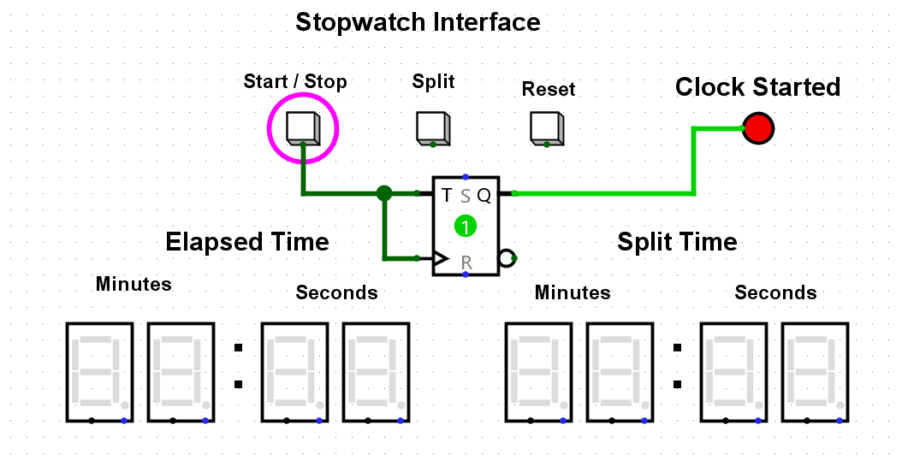

## Stage 2

In this stage a synchronous Counter which is created by D flip flop that can count up to 9 and also added an and gate which acts like switch in order to increment the counter only when the clock is in active state.

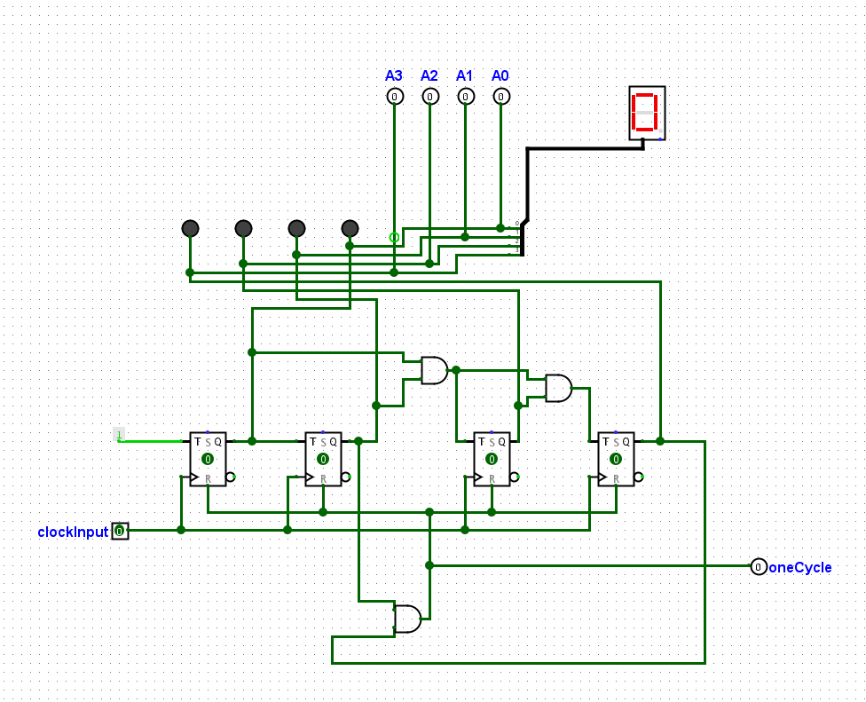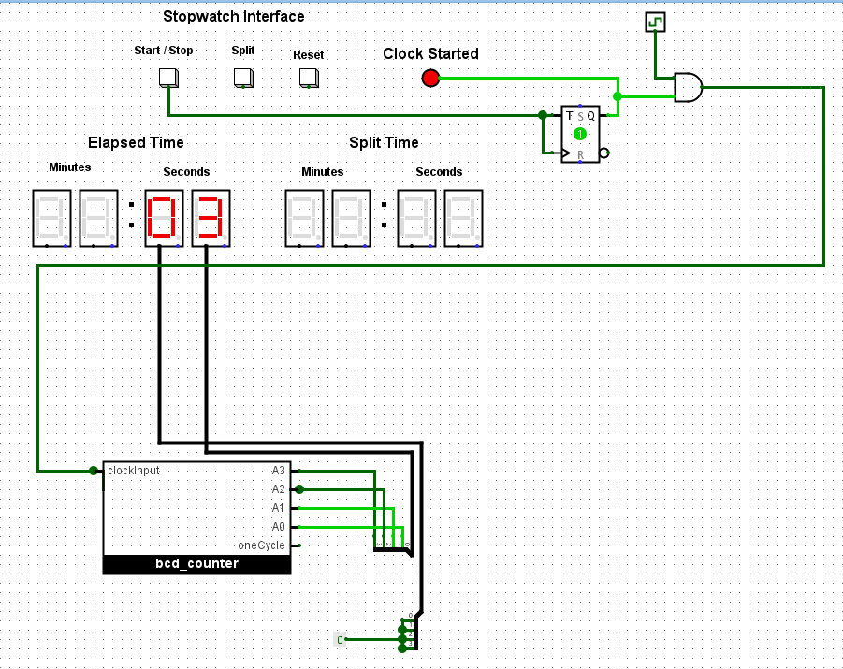

## Stage 3

Another synchronous Counter is created by D flip flop that can count up to 5 and the clock of this counter is given only when the LSD counter of second has completed one cycle. Also to work with Reset button the clock state is considered by using an “AND” gate and the start/stop state is also handled.

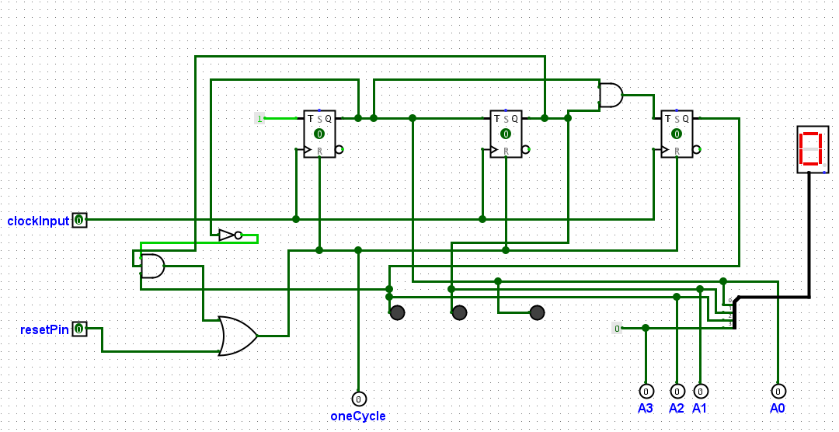 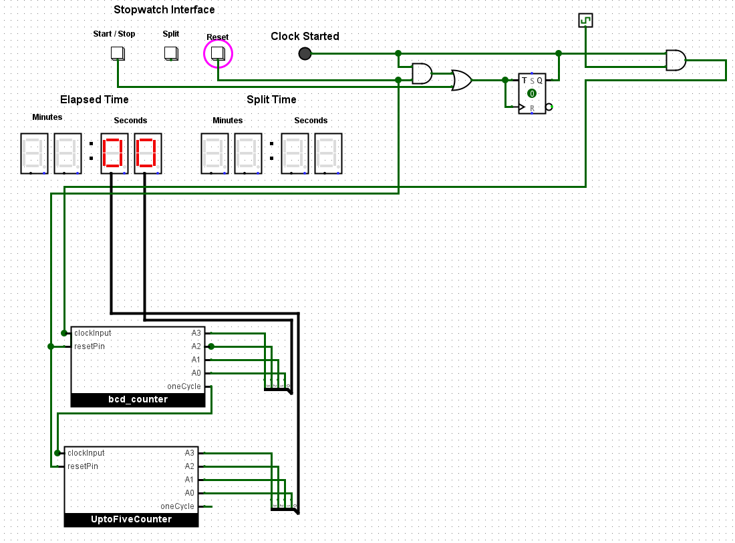

## Stage 4

Here “ElapsedTimeDisplay” circuit is introduced in order to make the main circuit less messy. This subcircuit implements the necessary circuit for the Displays . Also the LSD of Minute display is incremented when MSD of Second display completes one cycle. In the same way MSD of Minute display is incremented when LSD of Minute completes one cycle. Also another sub circuit “ControlUnit” is introduced in order to make the main interface cleaner . This is used to handle the buttons and their respective outputs.

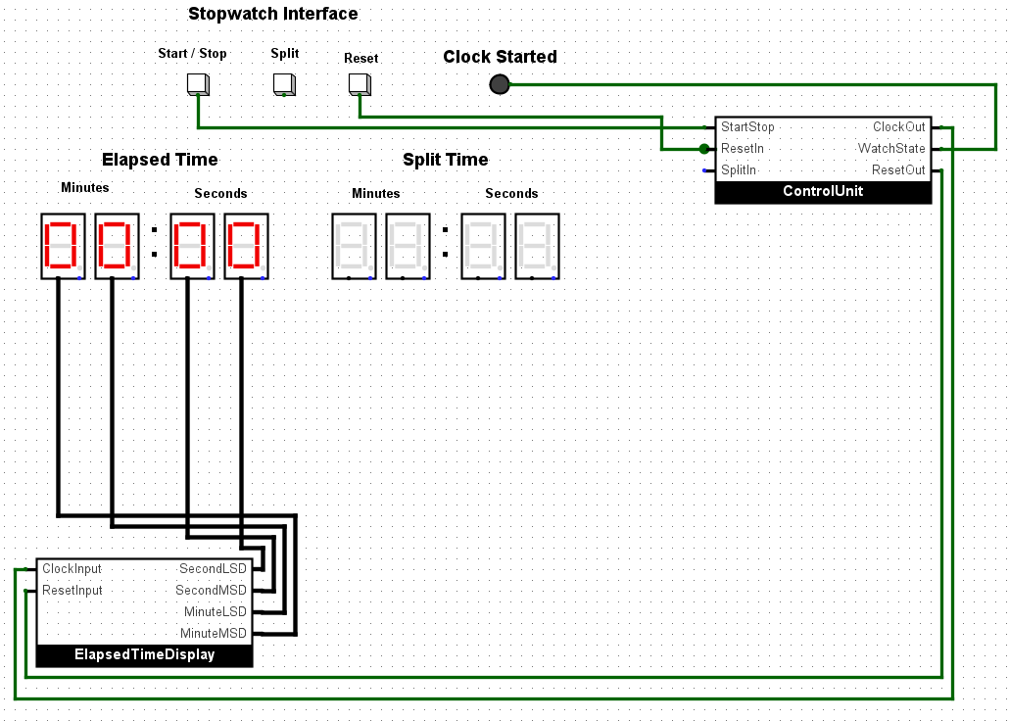 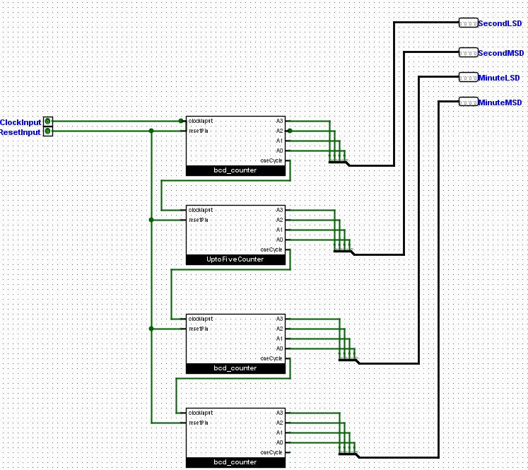

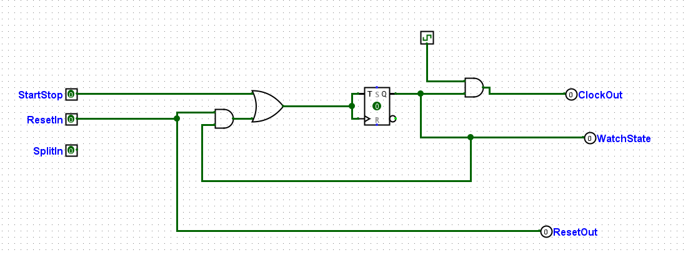

## Stage 5

Here “ControlUnit” sub circuit is modified to handle the split button . So when this button is pressed that moments time is sent to another new sub circuit “SplitTimeDisplay” which contains “FourBitDFF” sub circuits to store the value sent to it .

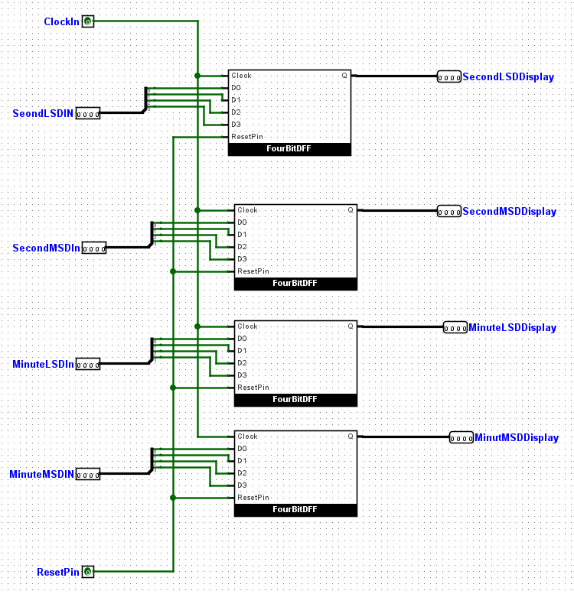 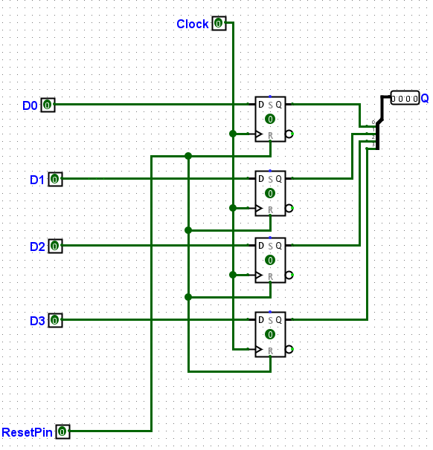

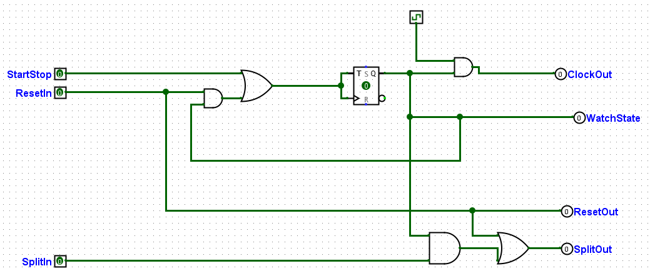

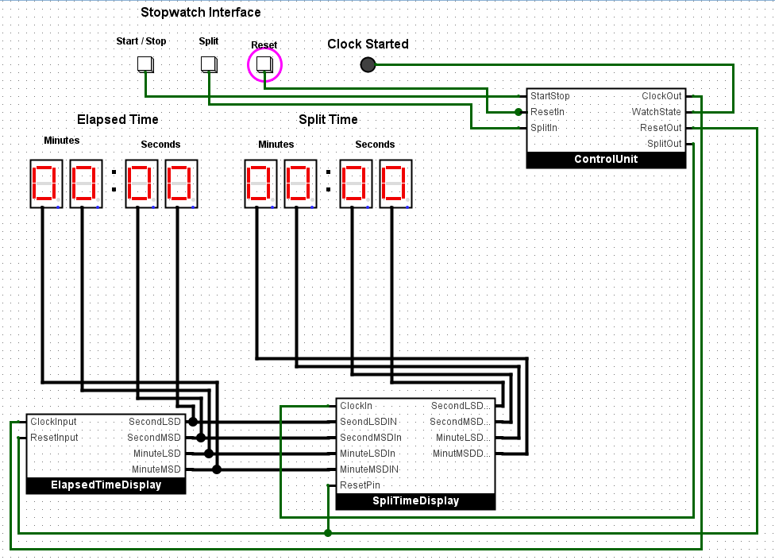

## Stage 6

In this stage the “SplitTimeDisplay” is modified so that it can pass the value to next display. Another 4 “FourBitDFF” are used in order to implement that. To ensure everything is done in one clock some adjustments are also made.

